**Hook-up between Jenkins job and Github:**

Step 1:

Create token.

Login github🡪setting🡪Developer Setting🡪Personal Access Token🡪Generate new token.

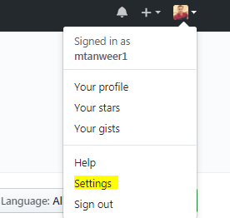

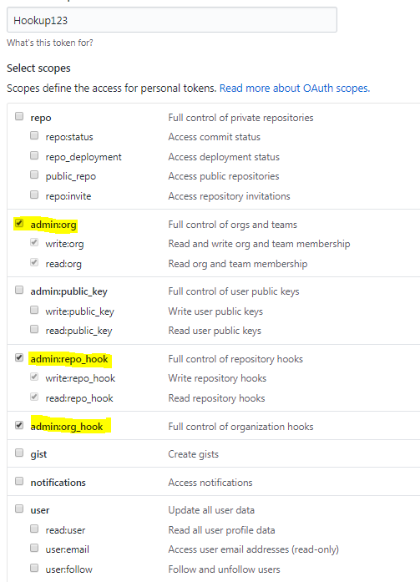

When you submit, your will get new token like below:

5660402a39cc60f3bf445dac2fd3feb08a075fa5

Step 2: create Webhook.

Go repository🡪setting🡪Webhook🡪

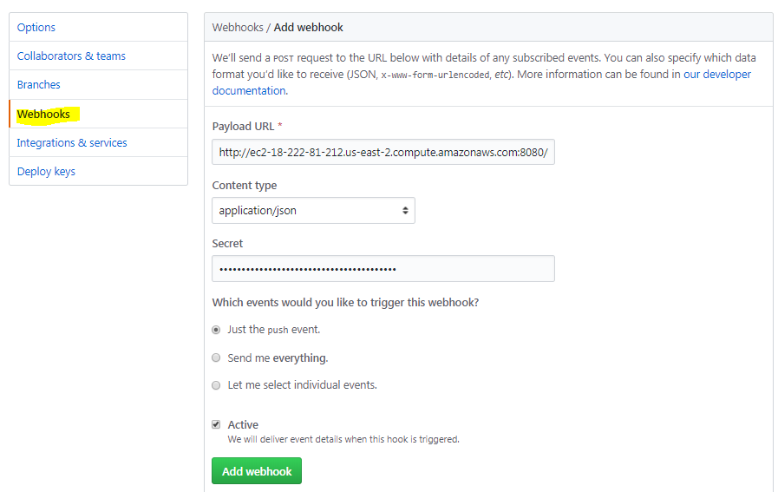

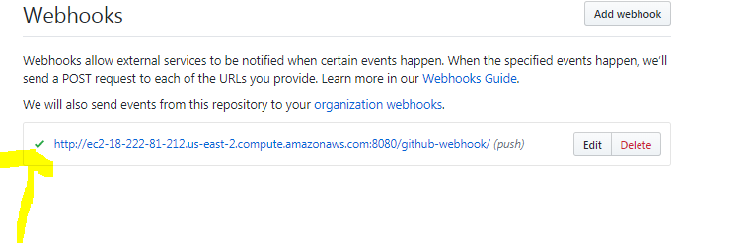

Step 3: Login Jenkins

Click “Credential” option

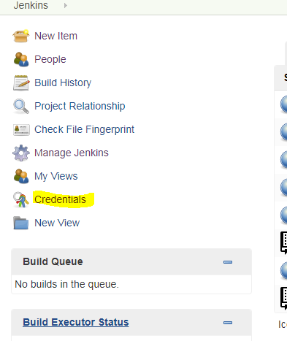

**Add credential:** select “Secret text” from drop down, paste secret key. Give ID name and Description. Hit OK

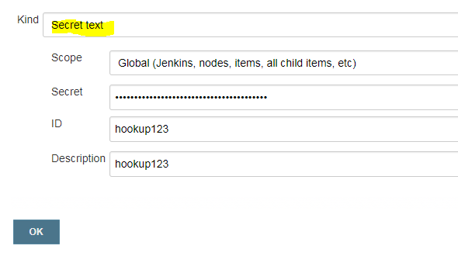

Step 4: Go Jenkins🡪 Manage Jenkins🡪Configure System🡪Add Github server

Add credential and click on “Test connection” then save

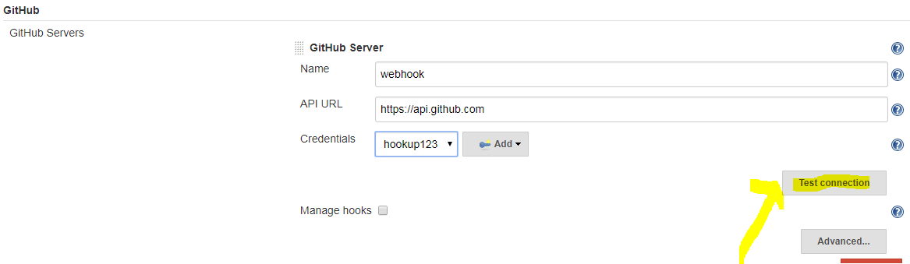

Step 5:

Create any new Project like Freestyle, Maven or Pipeline ….

I have created freestyle project here. Configure is below:

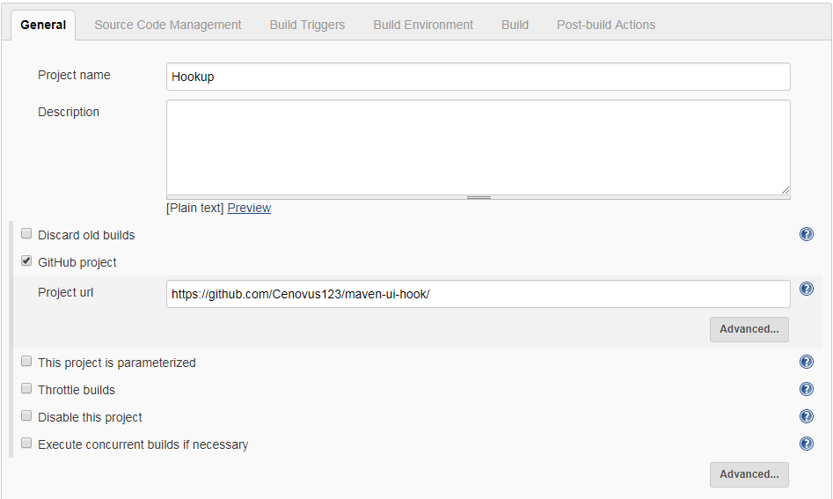

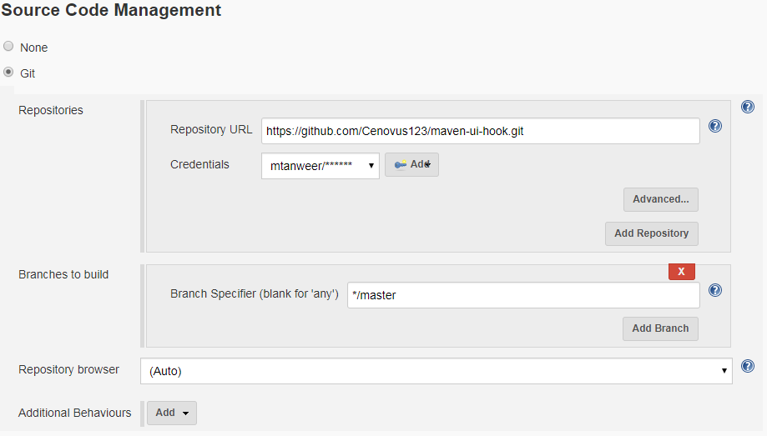

Ticked Build Triggers:

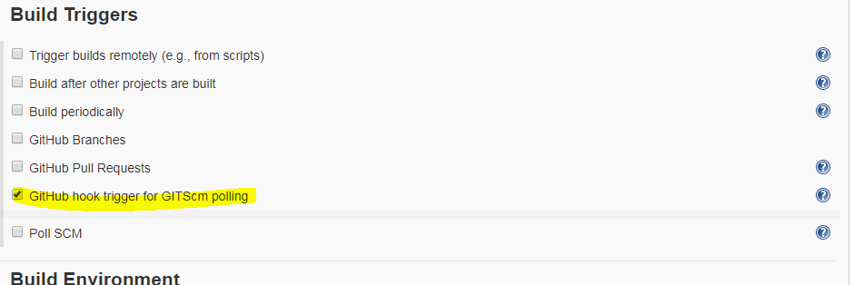

Step 6: Save the project

Step 7: when you will commit any changes in your repository on github, build will happen automatically.

